Subject No. 12
An online supermarket management system enables management staff, warehouse staff, saler and customer to use:
- Management staff: view the types of statistics: items, suppliers and revenue.
- Warehouse staff: import goods from suppliers, manage (add, delete, change) item information and supplier information, browse online orders and export to delivery staff.
- Saler: selling goods at the counter to customers
- Customer: register as a member, search, order online, buy directly at the counter

Considering two modules and answering questions:
- Customer registers as a member: selects the member registration menu → enters customer information, clicks add → the system saves to the database.
- Management staff views customer statistics: selects the menu to view statistical reports → chooses to view customer statistics by revenue → selects the start and end date → Views statistics of customers → clicks on a customer to view details → views list of related transactions.

Entity class diagram
- Step 1: Add id attribute to all class that is not inherit from other class
- Step 2: Add attribute type for all attribute. Attribute type must compatible with the chosen programming language
- Step 3: Change all association relationship to aggregation/composition
  - ImportInvoice associate Item create ImportItem: Change to ImportItem include ImportInvoice and Item
  - Item associate Order create ItemOrder: Change to ItemOrder include Item and Order
- Step 4: Add class atribute to entity class
  - ImportInvoice has Supplier, WarehouseStaff
  - ImportItem has ImportInvoice, Item
  - DirectOrder has Saler
  - OnlineOrder has DeliveryStaff
  - ItemOrder has Item, Order
  - Order has Customer
  - Invoice has Order
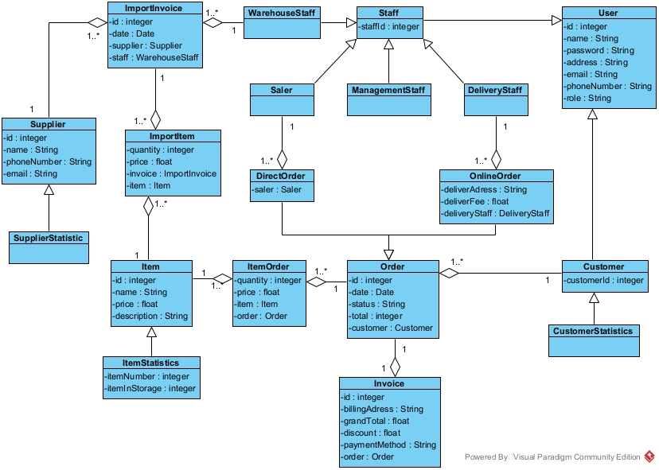

Database
- Step 1: For each class entity, create a table
  - User: tblUser
  - Staff: tblStaff
  - Customer: tblCustomer
  - Order: tblOrder
  - DirectOrder: tblDirectOrder
  - OnlineOrder: tblOnlineOrder
  - ImportInvoice: tblImportInvoice
  - Invoice: tblInvoice
  - Item: tblItem
  - Supplier: tblSupplier
  - ImportItem: tblImportItem
- Step 2: For each entity class, take all attribute type except entity attribute
  - tblUser:
    - id: integer(10)
    - name: varchar(255)
    - password: varchar(255)
    - address: varchar(255)
    - email: varchar(255)
    - phoneNumber: varchar(255)
    - role: varchar(255)
  - tblStaff:
    - staffId: integer(10)
    - tblUserid: integer(10)
  - tblCustomer:
    - customerId: integer(10)
    - tblUserid: integer(10)
  - tblOrder:
    - id: integer(10)
    - date: date
    - status: varchar(255)
    - total: float(10)
    - tblCustomercustomerId: integer(10)
  - tblInvoice:
    - id: integer(10)
    - billingAddress: varchar(255)
    - discount: float(10)
    - grandTotal: float(10)
    - paymentMethod: varchar(255)
    - tblOrderid: integer(10)
  - tblItemOrder
    - quantity: integer(10)
    - price: float(10)
    - tblItemid: integer(10)
    - tblOrderid: integer(10)
  - tblItem
    - id: integer(10)
    - name: varchar(255)
    - price: float(10)
    - description: varchar(255)
  - tblDirectOrder
    - tblStaffstaffId: integer(10)
    - tblOrderid: integer(10)
  - tblOnlineOrder
    - tblStaffstaffId: integer(10)
    - tblOrderid: integer(10)
    - deliverAdress: varchar(255)
    - deliverFee: integer(10)
  - tblImportInvoice
    - id: integer(10)
    - date: date
    - tblStaffstaffId: integer(10)
    - tblSupplierid: integer(10)
  - tblImportItem
    - quantity: integer(10)
    - price: float (10)
    - tblItemid: integer(10)
    - tblImportInvoiceid: integer(10)
  - tblSupplier
    - id: integer(10)
    - name: varchar(255)
    - phoneNumber: varchar(10)
    - email: varchar(255)
- Step 3: Consider quantity relationship between classes:
  - tblUser – tblStaff: 1 – 1
  - tblUser – tblCustomer: 1 – 1
  - tblStaff – tblDirectOrder: 1 – n
  - tblStaff – tblOnlineOrder: 1 – n
  - tblDirectOrder – tblOrder: 1 – 1
  - tblOnlineOrder – tblOrder: 1 – 1
  - tblCustomer – tblOrder: 1 – n
  - tblOrder – tblInvoice: 1 – 1
  - tblOrder – tblItemOrder: 1 – n
  - tblItem – tblItemOrder: 1 – n
  - tblStaff – tblImportInvoice: 1 – n
  - tblSupplier – tblImportInvoice: 1 – n
  - tblImportInvoice – tblImportItem: 1 – n
  - tblItem – tblImportItem: 1 -n
- Step 4: Add primary key and foreign key for all table
  - tblUser:
    - Primary Key: id
  - tblStaff:
    - Primary Key: staffId
    - Foreign Key: tblUserid → tblUser.id
  - tblCustomer:
    - Primary Key: customerId
    - Foreign Key: tblUserid → tblUser.id
  - tblOrder:
    - Primary Key: id
    - Foreign Key: tblCustomercustomerId → tblCustomer.customerId
  - tblInvoice:
    - Primary Key: id
    - Foreign Key: tblOrderid → tblOrder.id
  - tblItemOrder:
    - Primary Key: tblItemid, tblOrderid
      - Foreign Keys: tblItemid → tblItem.id,t blOrderid → tblOrder.id
  - tblItem:
    - Primary Key: id
  - tblDirectOrder:
    - Primary Key: tblOrderid
    - Foreign Keys: tblStaffstaffId → tblStaff.staffId, tblOrderid → tblOrder.id
  - tblOnlineOrder:
    - Primary Key: tblOrderid
    - Foreign Keys: tblStaffstaffId → tblStaff.staffId, tblOrderid → tblOrder.id
  - tblImportInvoice:
    - Primary Key: id
    - Foreign Keys: tblStaffstaffId → tblStaff.staffId, tblSupplierid → tblSupplier.id
  - tblImportItem:
    - Primary Key: tblItemid, tblImportInvoiceid
    - Foreign Keys: tblItemid → tblItem.id, tblImportInvoiceid → tblImportInvoice.id
  - tblSupplier
    - Primary Key: id
- Step 5: Remove abundant attribute
  - Attribute total in order
  - Attribute grandTotal in invoice
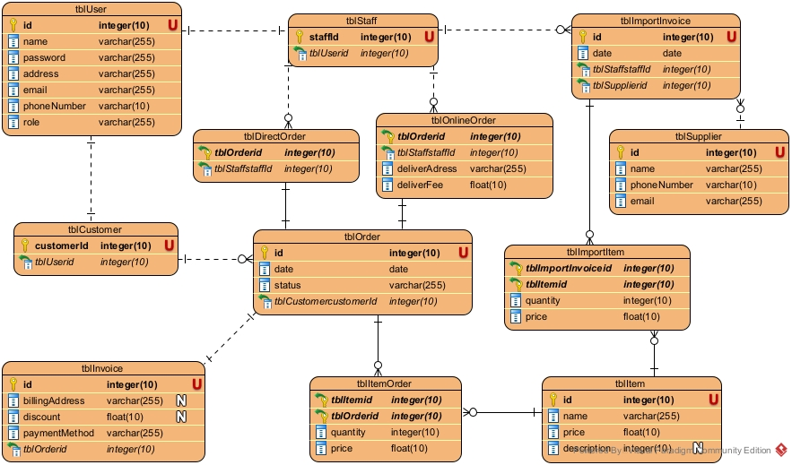

Class diagram

Module register as a member
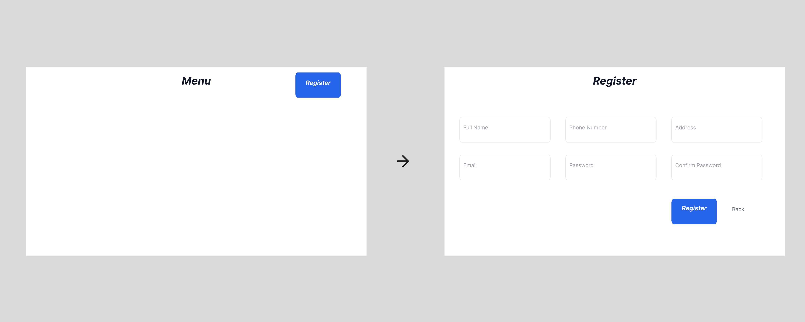
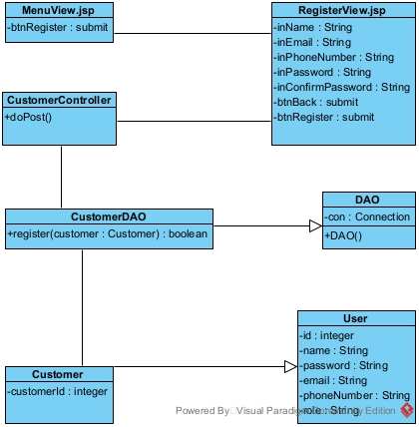

Module view customer statistics by revenue

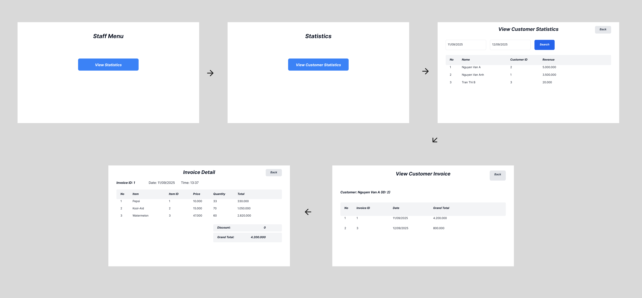

Activity diagram

Module register as a member
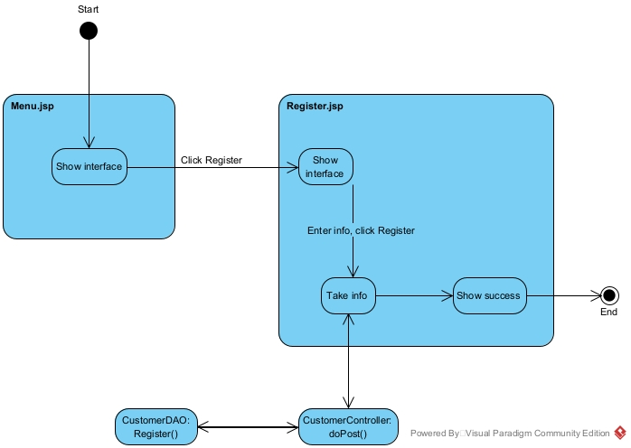

Module view customer statistics by revenue

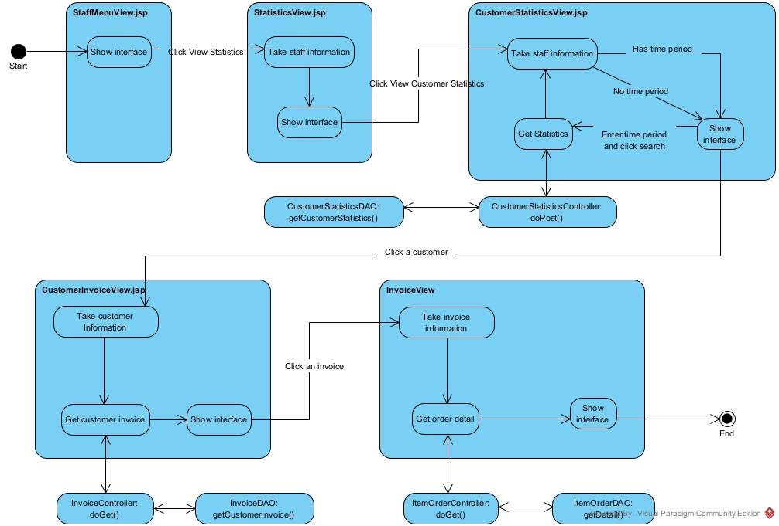

Scenario 3.0

Module register as customer
- In main menu interface, customer click register
- The interface MenuView.jsp call the interface RegisterView.jsp
- The interface RegisterView.jsp display itself to the customer
- The customer input information and click register
- The interface RegisterView.jsp call the class CustomerController
- The class CustomerController execute doPost()
- The class CustomerController call the class Customer
- The class Customer pack the information to a Customer object
- The class Customer return the Customer object to the class CustomerController
- The class CustomerController call the class CustomerDAO
- The class CustomerDAO execute register()
- The class CustomerDAO return the result to the class CustomerController
- The class CustomerController return the result to the interface RegisterView.jsp
- Class RegisterView.jsp display success message

Module view customer statistics by revenue
- In StaffLoginView.jsp, management staff enter username, password and click login
- The interface MenuView.jsp call the class StaffController
- The class StaffController call the class Staff
- The class Staff pack the information into a Staff object
- The class Staff return the object to the class StaffController
- The class StaffController execute doPost()
- The class StaffController call the class StaffDAO
- The class StaffDAO execute login()
- The class StaffDAO call the interface StaffMenuView.jsp
- The interface StaffMenuView.jsp display to the management staff
- The management staff click the View statistics button
- The interface StaffMenuView.jsp call the interface StatisticsView.jsp
- The interface CustomerStatisticsView.jsp display to the management staff
- The staff click View customer statistics by revenue
- The interface StatisticsView.jsp call the interface CustomerStatisticsView.jsp
- The interface CustomerStatisticsView.jsp display to the management staff
- The staff enter date and click search
- The interface CustomerStatisticsView.jsp call the class CustomerStatisticsController
- The class CustomerStatisticsController execute doPost()
- The class CustomerStatisticsController call the class CustomerStatisticsDAO
- The class CustomerStatisticsDAO execute getCustomerStatistics()
- The class CustomerStatisticsDAO call the class CustomerStatistics
- The class CustomerStatistics pack the information into a CustomerStatistics object
- The class CustomerStatistics return the object to the class CustomerStatisticsDAO
- The class CustomerStatisticsDAO return the result to the class CustomerStatisticsController
- The class CustomerStatisticsController return the result to the interface CustomerStatisticsView.jsp
- The interface CustomerStatisticsView.jsp display the result to the management staff
- The management staff click a customer
- The interface CustomerStatisticsView.jsp call the interface CustomerInvoiceView.jsp
- The interface CustomerInvoiceView.jsp call the class InvoiceController
- The class InvoiceController execute doGet()
- The class InvoiceController call the class InvoiceDAO
- The class InvoiceDAO execute getCustomerInvoice()
- The class InvoiceDAO call the class Invoice
- The class Invoice pack the information into an Invoice object
- The class Invoice return the result to the class InvoiceDAO
- The class InvoiceDAO return the result to the class InvoiceController
- The class InvoiceController return the result to the interface CustomerInvoiceView.jsp
- The interface CustomerInvoiceView.jsp display the result
- The management staff click an invoice
- The interface CustomerInvoiceView.jsp call the interface InvoiceView.jsp
- The interface InvoiceView.jsp call the class ItemOrderController
- The class ItemOrderController execute deGet()
- The class ItemOrderController call the class ItemOrderDAO
- The class ItemOrder execute the function getOrderDetail()
- The class ItemOrder call the class Item
- The class Item pack the information into an Item object
- The class Item return the object to the class ItemOrderDAO
- The class ItemOrderDAO call the class ItemOrder
- The class ItemOrder pack the information into an ItemOrder object
- The class ItemOrder return the result to the class ItemOrderDAO
- The class ItemOrderDAO return the result to the class ItemOrderController
- The class ItemOrderController return the result to the interface InvoiceView.jsp
- The interface InvoiceView.jsp display the result to the management staff

Sequence diagram

Module register as a member
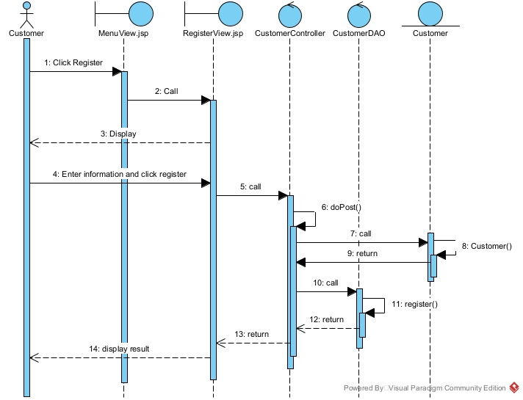

Module view customer statistics by revenue
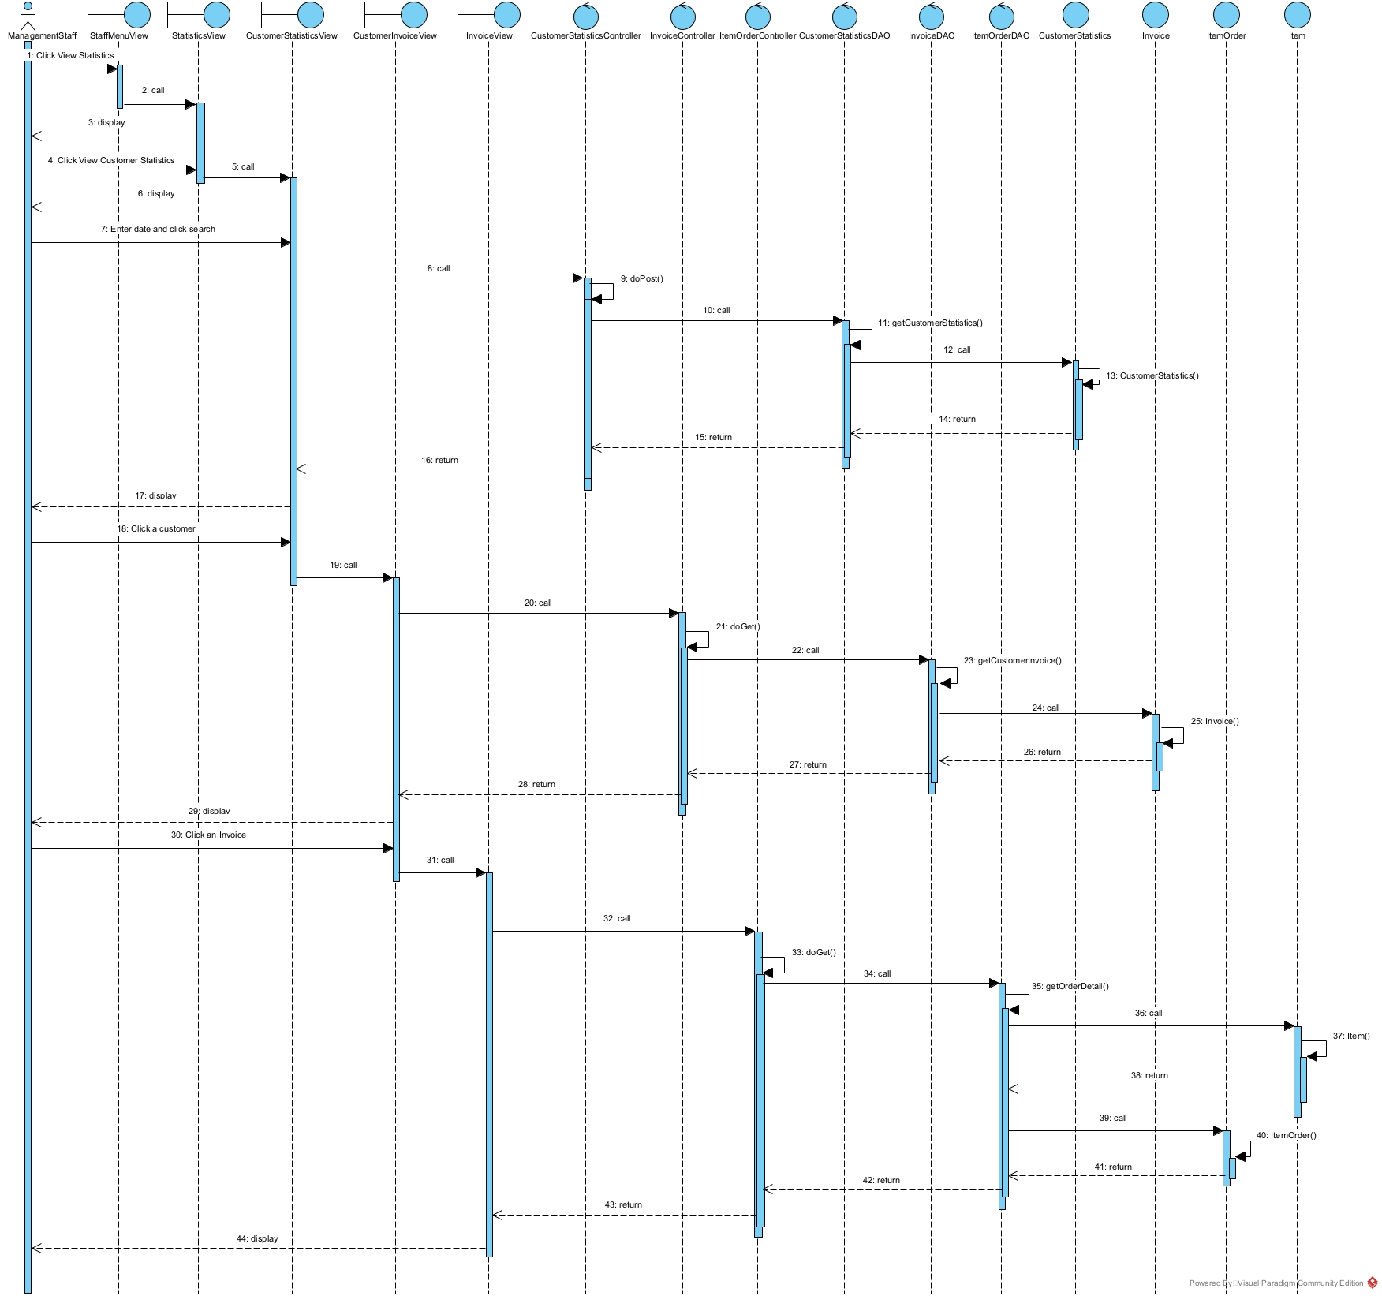

Package Diagram
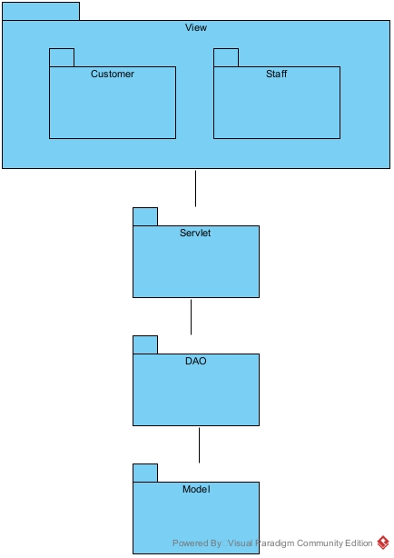

Deployment Diagram
